# Amazon Relational Database Service (Amazon RDS)

🔹 Amazon RDS is a managed service for relational databases in AWS.

* 🚀 Easy to set up, operate, and scale.
* 💰 Offers cost-efficient and resizable capacity.
* 🔄 Supports industry-standard databases (like MySQL, PostgreSQL, etc.).
* 🛠️ Handles provisioning, patching, backups, and failover automatically.
* 📊 Frees you to focus on your application, not DB admin tasks.

🔹 Key Advantages of Amazon RDS:

* ✅ Supports familiar DB engines (MySQL, Oracle, SQL Server, etc.)
* 🔧 Auto handles backups, patching, and recovery
* 💾 Reliable restore via automated/manual backups
* 🔄 High availability + read replicas for scaling
* 🔐 Strong security via IAM + VPC integration

**Comparison of responsibilities with Amazon EC2 and on-premises deployments**

| Responsibility | On-Premises | Amazon EC2 | Amazon RDS 🏆 (Recommended) |
| --- | --- | --- | --- |
| Hardware Provisioning | User-managed | AWS-managed | AWS-managed |
| OS & DB Software Installation | User | User | AWS |
| Backups | Manual | Manual or scripted | Automatic |
| Patching | Manual | Manual | Automatic |
| High Availability & Failover | Manual setup | Manual setup | Built-in support |
| Scaling | Limited | Manual (separate) | Easy/Auto |
| Security (IAM, VPC) | User-defined | AWS + user | AWS + user |
| Failure Recovery | User effort | User effort | AWS-managed |

🔹 Summary:

* On-premises: Full control, but full burden.
* EC2: More flexible, but still requires manual DB management.
* RDS: Hands-off and reliable — great for saving time and reducing risk.

## Amazon RDS shared responsibility model

🔹 AWS (RDS) is responsible for:

* Managing the infrastructure (hardware, networking, storage)
* Running and maintaining database software
* Handling backups, patching, failover, and availability
* Ensuring physical security and compliance of the cloud environment

🔸 You (the user) are responsible for:

* Query tuning to optimize performance
* Designing efficient schema and indexes
* Monitoring performance using tools like RDS Performance Insights
* Managing data access, IAM roles, and encryption settings
* Understanding workload patterns and adapting your setup accordingly

Think of it like this: AWS sets the stage and keeps the lights on, but you're the director of the performance.

🔹 Amazon RDS DB Instance Overview:

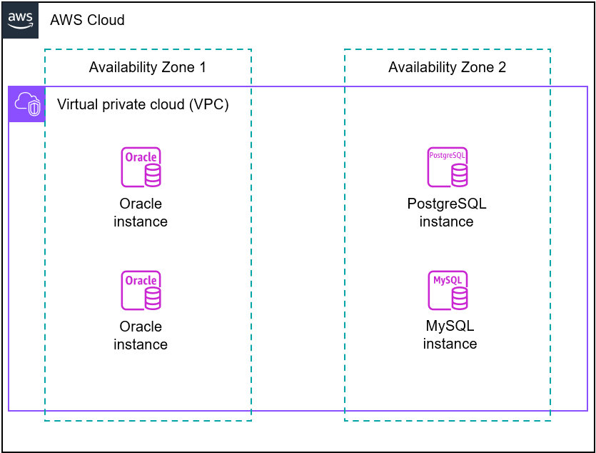

* 🧱 Basic unit of RDS — isolated DB environment in the cloud
* 📦 Holds one or more user-created databases
* 🛠 Managed using AWS CLI, RDS API, or AWS Console
* 💻 Accessed via standard DB tools you already use
* 🌐 Hosted in Virtual Private Cloud (VPC) across Azs

🔸 Key Topics:

* 🏗 Architecture — Example app setup using RDS
* ⚙️ DB Engines — MySQL, PostgreSQL, Oracle, etc.
* 🧠 Instance Classes — Memory/CPU configurations
* 💽 Storage Types — General Purpose, Provisioned IOPS
* 🔐 VPC Integration — Network isolation and control

### **Amazon RDS application architecture: example**

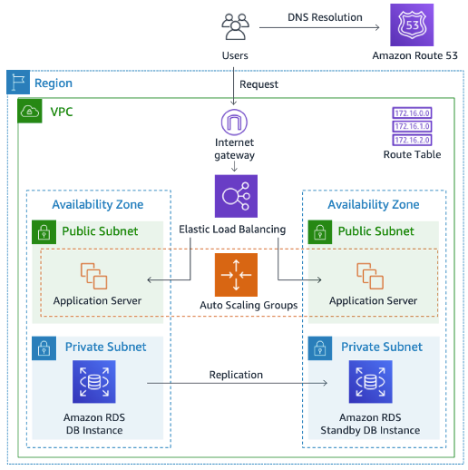

🔹 AWS Architecture – Key Components:

* ⚖️ Elastic Load Balancer (ELB)
  + Routes user traffic
  + Distributes load across app servers
  + Forwards requests to EC2 instances
* 🖥️ Application Servers (on EC2)
  + Host application logic
  + Deployed in public subnets across multiple AZs
  + Connect to RDS DB for data operations
* 🗃️ RDS DB Instances
  + Located in private subnets (not internet-accessible)
  + Handle database storage and queries
  + Primary DB replicates to a Read Replica for high availability
  + Accessible only by app servers within the VPC

🔹 DB Engine = Database Software on RDS instance

🔸 Supported Engines:

* IBM Db2
* MariaDB
* Microsoft SQL Server
* MySQL
* Oracle
* PostgreSQL

🔹 Things to Note:

* 🎯 Features vary by engine & version
* 🌍 Feature support also depends on AWS Region
* ⚙️ Behavior controlled via DB parameter groups

### **DB instance classes**

🔹 What It Is Defines the compute + memory capacity for your RDS instance.

🔸 Types of Instance Classes

* ⚙️ General Purpose → db.m* (balanced performance)
* 🧠 Memory Optimized → db.r*, db.x*, db.z* (for heavy read/write)
* 🚀 Compute Optimized → db.c* (CPU-intensive workloads)
* 🌱 Burstable → db.t* (low-cost, variable workloads)

🔹 Example db.m7g.2xlarge = 7th gen general-purpose (Graviton3) with 2xlarge size.

🔸 Scalability You can resize any time (e.g., from 2xlarge to 4xlarge) as app needs grow.

### **🗄️ DB Instance Storage Types**

* General Purpose (SSD) – Balanced, cost-effective. Ideal for dev/test.
* Provisioned IOPS (PIOPS) – High performance. Best for production.
* Magnetic – Legacy only. Avoid for new systems.

✔️ Choose based on performance + cost needs 📏 Ensure enough storage for growth and feature usage

### **🌐 DB Instances in Amazon VPC**

* Hosted inside a Virtual Private Cloud
* You control IP range, subnets, routing, and access
* Works the same as outside VPC
* No extra cost for using VPC
* Uses NTP to stay time-synced

### 🌍 **AWS Regions & Availability Zones (AZs)**

* Region = Geographic area (e.g., Asia, Europe) with multiple data centers
* Availability Zone (AZ) = A separate, isolated data center within a Region
* RDS lets you deploy across multiple Regions for global resilience
* Cross-Region replication keeps standby DB synced (asynchronously)
* If one Region fails, another Region takes over — high availability ensured

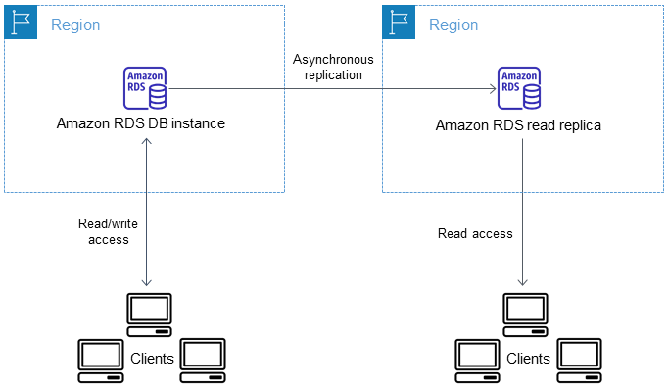

### **🏢 Availability Zones (AZs) – Key Points**

* AZ = Isolated data center within an AWS Region
* Built to handle failures independently from other AZs
* Connected with low-latency, high-speed networking
* Launching RDS DB instances across AZs = High Availability
* Protects your app from single-location outages

### **🏢 Multi-AZ Deployment (Amazon RDS)**

* 🎯 Purpose: Increases availability & fault tolerance
* 🌍 How it works:
  + Primary DB in one AZ
  + Standby replica in a different AZ (auto-managed by AWS)
  + Synchronous replication keeps standby in sync
* 🚫 Standby does NOT serve reads (except in Multi-AZ DB clusters)

### **✅ Benefits**

* 🔁 Data redundancy + automatic failover
* 🚫 No I/O freeze during backup
* 📉 Reduces latency spikes
* 📖 (Optional) Read scaling with clusters only

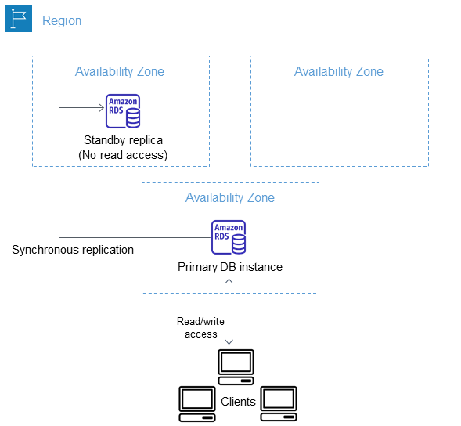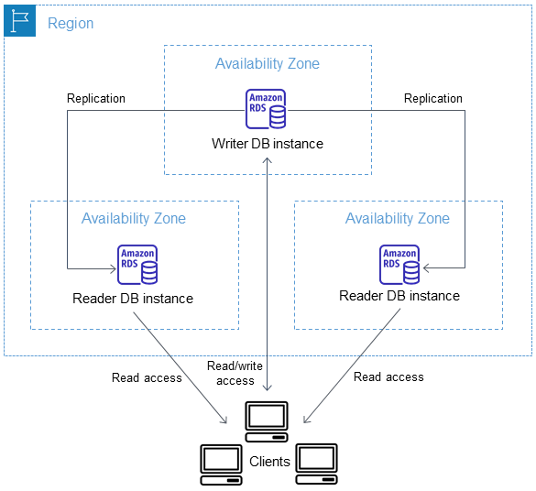

### **🔐 Access Control with Security Groups**

* Security Group = Virtual firewall for controlling DB access
* Define rules for who can connect (by IP or EC2 instance)
* Can be attached to one or more DB instances

### **🧱 Example Setup (VPC)**

* ec2-rds-x — For app servers, allows inbound from client IPs
* rds-ec2-x — For RDS DB, allows inbound only from ec2-rds-x
* ✅ Clients talk to app server
* ❌ Clients can’t access DB directly
* ✅ App server can access DB securely

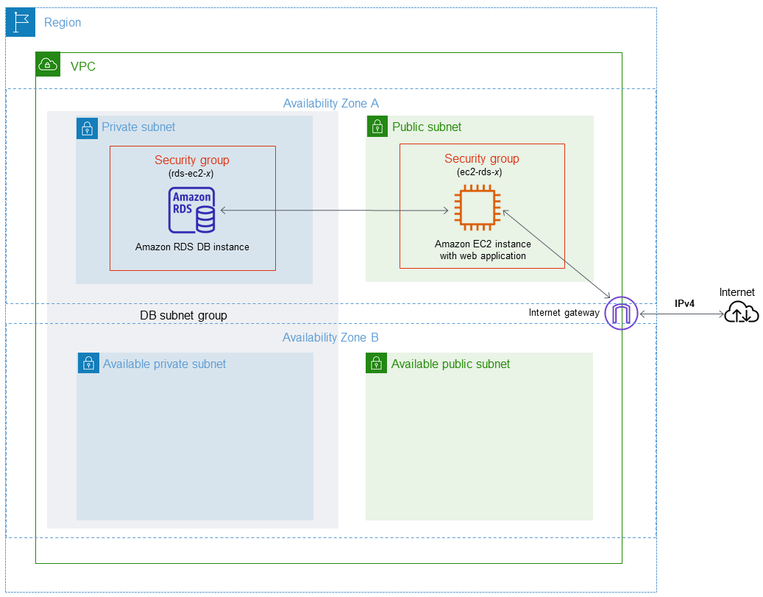

### **📊 Amazon RDS Monitoring Overview**

* 🧭 RDS Console / CLI / API
  + View DB instance status
  + Get automated recommendations
* ⏱️ Amazon CloudWatch
  + Tracks performance metrics every minute
  + Shows charts in RDS Console
  + Set alarms for threshold-based alerts
  + 🎉 No extra cost for RDS metrics
* 🚦 Performance Insights
  + Analyzes DB load patterns
  + Helps spot slow queries or workload spikes
* 📡 Enhanced Monitoring
  + Real-time OS-level metrics
  + Great for detailed system-level diagnostics
* 🔗 Integrated Services
  + Works with CloudWatch Logs, EventBridge, and DevOps Guru
  + Enables logging, event-driven responses, and smart issue detection

### **🖥️ User Interfaces to Amazon RDS**

* AWS Management Console
  + Web UI — manage DBs with clicks, no coding needed
* AWS CLI
  + Command-line access to RDS features (interactive + scriptable)
* Amazon RDS APIs & SDKs
  + Programmatic control
  + SDKs simplify auth, retries, errors
  + Available in multiple programming languages

### **💵 Pricing Options**

* On-Demand
  + Pay-as-you-go, flexible, no commitment
* Reserved Instances
  + Commit for 1–3 years, lower cost for steady workloads